# Running Titanium on Tizen. Environment configuration

## Installing Tizen development Environment

#### Download Tizen SDK 2.0

Download Install Manager and Image at: <https://developer.tizen.org/sdk>

For Windows 32bit

<http://download.tizen.org/sdk/InstallManager/tizen-sdk-2.0-windows32.exe>

<http://download.tizen.org/sdk/sdk-images/tizen-sdk-image-2.0.0a-windows32.zip>

For Windows 64bit

<http://download.tizen.org/sdk/InstallManager/tizen-sdk-2.0-windows64.exe>

<http://download.tizen.org/sdk/sdk-images/tizen-sdk-image-2.0.0a-windows64.zip>

Install 64bit version if you are using Window 7 64bit. Do not try install x64 InstallManager or Image . All next steps assumes that installation files for x64 are used.

#### Install Tizen SDK

Run tizen-sdk-2.0-windows64.exe and click button ***Advanced***

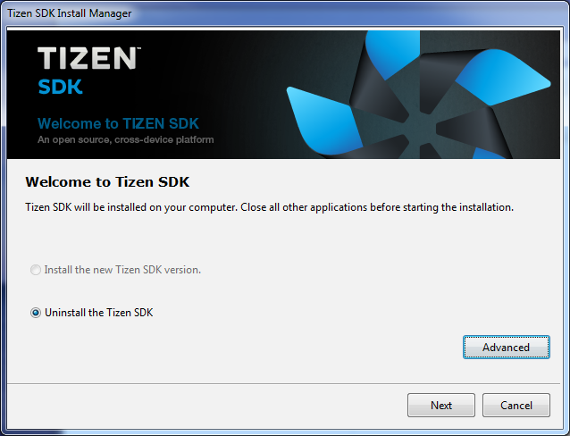

In the next window select radio button “SDK Image”

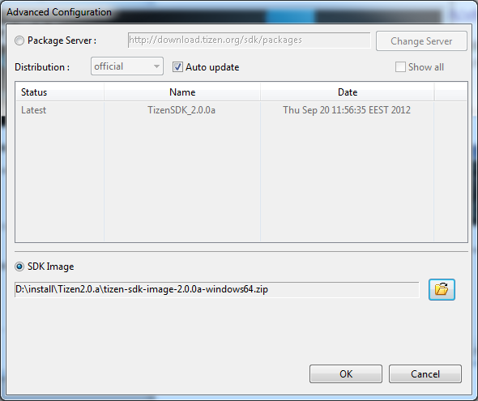

And select downloaded tizen-sdk-image-2.0.0a-windows64.zip . Click Ok.

SDK installation starts. Use default settings for all next steps and go throw installation process. As result Tizen SDK installed into ***C:\tizen-sdk*** .

#### Install Intel HAXM for Tizen

Without HW Acceleration Tizen emulator performance on Windows are far away from excellence even with Core i7 processor. It is mandatory configure hardware acceleration. Go to page <https://developer.tizen.org/downloads/sdk/installing-sdk/hardware-accelerated-execution-manager>

And download and install [IntelHaxmTizen.exe](http://download.tizen.org/sdk/haxm/beta/IntelHaxmTizen.exe)

Important: HAXM for Tizen conflicts with HAXM for Android. Uninstall Android version first.

Reboot your computer.

#### Create Tizen Emulator instance

Run ***Tizen Emulator Manager***. Path to it: ***C:\tizen-sdk\tools\emulator\bin\emulator-manager.exe***

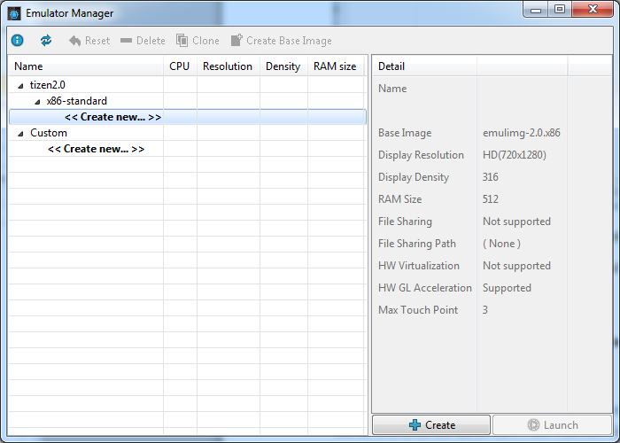

Click x86-standart->Create New and then click button Create

Ensure that following options are set:

* Name: tizenEmulator
* Display Resolution: 480x800
* RAM Size: 512 or 1Gb
* HW Virtualization: disabled or Non Supported
* HW GL Acceleration: Supported.

Beware of HW Virtualization options. It should be enabled and show “Supported”. If it is disabled try to check section Install Intel HAXM for Tizen once more. Intel Hardware Accelerated Execution Manager and installation instruction available here: <https://developer.tizen.org/downloads/sdk/installing-sdk/hardware-accelerated-execution-manager>

Ready to use emulator looks as on the picture:

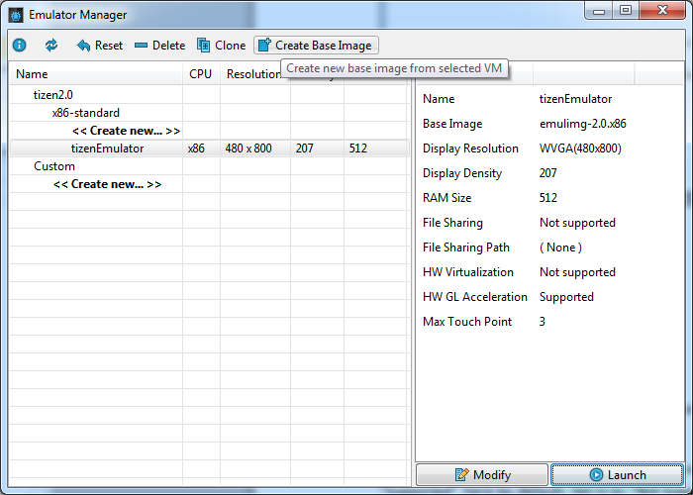

Click Launch button to start it.

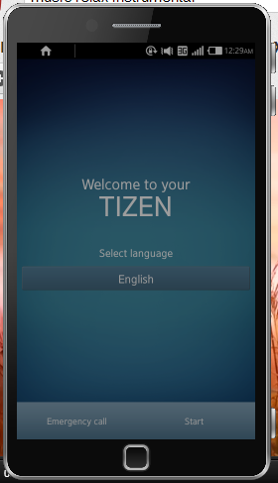

For first start Tizen shows welcome screen. Click Start on it. On the next screen click “Next” and click “Finish” on the last screen.

Ready to use emulator looks as on the picture

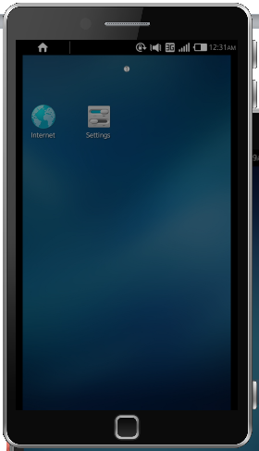

It is highly recommended to use high performance system as host for a Tizen emulator. It is quite slow and irresponsible.

#### Check is emulator available

It is important to check is there are connection between developer tools and emulator.

In console run C:\tizen-sdk\tools\ide\bin\web-list.bat

It should shout that one emulator instance available.

Frequently it just freezes. In this case you have to restart thing called “Samsung Debug Bridge”. It is just a bit modified Android tool originally called adb. To restart execute sdb located in ***C:\tizen-sdk\tools\:***

***sdb kill-server***

***sdb start-server***

***sdb devices***

First two commands restarts service. Last one shows list of available devices/emulators after successful restart.

## Installing Titanium Development environment

Use as reference CLI Quick Start from Titanium Command-Line Interface Reference here <http://docs.appcelerator.com/titanium/3.0/#!/guide/Titanium_Command-Line_Interface_Reference>

### Install Node.js

The CLI requires Node.js 0.8 or later. If you don't have Node installed, install it from:

[nodejs.org](http://nodejs.org/)

Download node.js at <http://nodejs.org/download/> and install it.

### Install and Configure the CLI

#### Install the titanium CLI.

***npm install titanium -g***

#### Log in using your Appcelerator credentials.

***titanium login***

You are prompted for your Appcelerator network login and password.

#### Download and Install Titanium Mobile 3.0.0 or newer SDK with Tizen support

Download latest Titanium Mobile SDK with Tizen support. <TBD: link to SDK>

If cli failed to do this, just download SDK manually from <http://builds.appcelerator.com.s3.amazonaws.com/index.html> and install it with Titanium Studio (Help-> Install SDK):

1. Run Titanium Studio
2. Go to menu Help->Install Specific Titanium SDK
3. Select “Install From URL” and select SDK zip file via Browse button

#### Configure CLI (optional).

***titanium setup***

The script prompts you to enter basic information, such as your name, default locale, default SDK version, and default workspace folder.

Important: set default sdk in this command because build script temporally does not allow select SDK and used default.

#### Ensure that Java is installed and available

Java runtime is required and should be available in PATH.

To check it execute in console:

**java -version**

At least java 1.6 is required to build Tizen applications. Install it from official site <http://java.com/en/>

## Building and Running Sample application

### Source control

Source code repository is: <https://github.com/appcelerator/titanium_mobile_tizen> Check that you can see it in browser before proceeding with next steps.

Get sources into your work folder with git clone command:

***git clone https://github.com/appcelerator/titanium_mobile_tizen.git***

This command will ask you for github credential.

### Preparing required nodejs modules for work

Go to into folder titanium_mobile_tizen in any console and execute

***npm install***

It will download all required nodejs modules (***see titanium_mobile_tizen/package.json*** for dependencies)

#### Build KitchenSink application

In any console go to in ***<PATH_TO_REPO>\titanium_mobile_tizen\tests\samples\KitchenSink***

In current folder execute:

***titanium build --platform=tizen***

On success build ***<PATH_TO_REPO>\titanium_mobile_tizen\tests\samples\Tizen\build\tizen*** contains file tizenapp.wgt

#### Run KitchenSink application inTizen Emulator

Tizen SDK since 2.0 contains CLI tools to install and run application on emulator/device. We needs web-run.but for this. It is located in <TIZEN_SDK> folder. By default it is C:\tizen-sdk.

Run this command:

<TIZEN_SDK>\tools\ide\bin\web-run.bat

***web-run.bat -w "tizenapp.wgt" -id http://appcelerator.com***

Important: It may take several minutes to load and run the application on emulator.

# Building Titanium Mobile SDK for Tizen

Tizen implementation in Titanium Mobile SDK is unique due to it dependency on Mobile Web. Really it is MobileWeb extension and some tools to build Tizen`s wgt files. There is special script to add Tizen platform into

How to create SDK with Tizen support from regular Titanium Mobile SDK (works on Windows and linux systems, used node.js):

1. Get all sources from **titanium_mobile_tizen** repo into folder <titanium_mobile_tizen>.
2. Download latest (3.0.0) SDK for Win32 from <http://builds.appcelerator.com.s3.amazonaws.com/index.html> into folder <build_dir>
3. Create temporary folder <build_dir>/temp
4. In console go into folder <titanium_mobile_tizen> and execute in it **node build.js <build_dir>\mobilesdk-3.0.0.v<NUMBER>-win32.zip <build_dir>/temp**
5. In this command first parameter is path to source sdk and second is path to temporary folder used for unzip and other operations. This folder should not contains any additional files.
6. After successful build file <build_dir>\mobilesdk-3.0.0.v<NUMBER>-win32-tizen.zip exists